Oxford City Council Corporate Procurement Strategy   
November 2022 – October 2025

Version: 5.8



Content

Contents

1. Background 4

1.1 Success to build on as a result of the first iteration of the procurement Strategy relating to Social, equalities and environmental impacts. 4

2020-21 4

2021 – 2022 4

2. Setting the Scene for Procurement 5

2.1 Overview 5

3. Setting the Direction for Procurement 6

3.1 Our Purpose 6

3.2 Ambition 7

3.3 Vision 7

4. Our Aims, Objectives and Key Priorities 7

4.1 Aims 7

4.2 Objectives 8

4.3 Key Priorities 9

5. Measuring and Monitoring our Performance 9

5.1 Spend 9

5.2 Local (OX postcode) and SME (Small/Medium Enterprise) Spend 10

5.3 Contract Register_Pipeline 10

5.4 Exemption Requests 11

5.5 Tenders undertaken via the Procurement Portal 12

5.6 Transparency reporting 12

5.7 Key Performance Indicators 13

6 Contract management 14

7. Social Value 14

8 Sustainable Procurement 15

9 Ethical Procurement 15

10 Conclusion AND SUMMARY 16

11 Action Plan to deliver the strategy 17

12. Glossary 17

Appendix 1 19

How Procurement will support internal stakeholders 19

Contract Management 19

Integrated Contract and Commercial Capability 19

Contract Lifecycle Management 20

Appendix 2 22

KPI and SLA Monitoring 22

KPI Reporting 22

Social Value, Sustainability and Ethical Procurement 23

Social Value 23

Sustainable Procurement 23

Ethical Procurement 27

Appendix 3 Key Priority Action Plan and reporting framework 29

# 1. Background

Welcome to the 2nd iteration of the Procurement Strategy designed to set out the proposed actions for the coming 3 years.

This Procurement Strategy has been prepared during a period of an ever changing procurement agenda and is mindful of the current financial climate. Whilst the strategy sets out the aims and goals for the November 2022- October 2025 period it will be reviewed on an annual basis, to reflect any changes in both national and local policies and priorities. The following points are relevant to this strategy.

* £300 Billion is spent through public procurement annually on goods, works and services.
* How public money is being spent is changing with the introduction of the Procurement Bill 2022, cutting 350 EU rules and 4 existing sets of UK Regulations to a single Regulatory Framework.
* This Procurement Strategy has been designed to align to the Council’s values and priorities along with the procurement strategies of the Council’s wholly owned companies to ensure that the group benefit from both financial savings and efficiencies from joint procurements and frameworks wherever possible.
* This Procurement Strategy is designed to support a culture of devolved procurement within the constraints of the Procurement Regulations and the Council’s Constitution.
* The Council spends circa £150m per annum on procuring goods, services and works including Capital, £100m excluding Capital.
* Procurement will work with all of the Council service areas and its wholly owned companies within the Group (Oxford Direct Services Limited (ODSL), Oxford Direct Services Trading Limited (ODSTL), Oxford City Housing Limited (OCHL) and Oxford City Housing Development Limited (OCHDL) to understand the environment it is working within and the impact to the entity or service area to enable effective planning of how procurement can support.
* This strategy further embeds the council’s commitment to Community Wealth Building and delivering Social Value through procurement that began with the previous strategy.

## 1.1 Success to build on as a result of the first iteration of the procurement Strategy relating to Social, equalities and environmental impacts.

### 2020-21

During the 2020 to 2021 procurement strategy for the first time a 5% weighting to tenders was applied (where practical and proportionate to do so) relating to social value. This resulted in a range of supplier commitments including:-

* The identification of a range of social and physical infrastructure to deliver development which is sustainable
* Work to quantify the costs of low carbon construction and find ways to meet carbon targets cost effectively
* Support of the Oxford Living Wage
* Donation of gifts to the charity Crisis
* Support for CV/Job applications and / or local job fairs.

The value in the Social Value commitments in the initial year of tracking was not recorded.

### 2021 – 2022

During 2021 to 2022 where proportionate to do so, the Council applied a weighting of between 5% and 10% to tenders for the provision of goods, works and or services, and promoted 10% towards the end of the 2022 financial year in-line with best practice. Procurement began tracking social value on the awarded contracts to ensure that supplier promises were delivered. This resulted in a range of commitments to the Council supporting local communities of Oxford, including:

* Support of Oxford Living Wage
* Wellbeing white paper, podcasts, work with SME and Local Business
* Student Placements
* Engaging local schools with the CIPFA Management games
* Use of low loss/high efficiency transformers
* Environmental management KPI’s to reduce carbon footprint
* Excess food donation to local community
* Commitment to work with ASPIRE and other VCSE’s
* H & S training to boost employment
* Sports sponsorship
* Donation of equipment
* Coaching discussions for business impacted by Covid-19
* Support of woodland trust, planting trees
* 5 paid work placements for students at Blackbird Leys College, and 5 free legal consultation for businesses in Oxford.
* Donate assistive listening system to specialist deaf schools £2,650 (excl.VAT) of audio-visual and/or IT equipment in 2022.
* Invest back 2% of service fee into a Community venture of our choice and offer a ‘living lab’ service enabling students to get involved in the local project to gain insight and exposure to the construction industry
* £500 donation per year to oxford's Community Impact Fund 'Big Ideas'
* Proposal for charitable morning to partake in a pre-agreed event to tackle environment issues

The charts below reflect the improvements that have been made in both social value commitments made by suppliers at their bid stage and the tracking by both procurement and the contract manager throughout contract delivery.

# 2. Setting the Scene for Procurement

## 2.1 Overview

Procurement is the process through which an organisation establishes contracts for goods, works, services and utilities.

Procurement at the Council has oversight of only a small part of the Council’s total budget and cannot manage all day to day dealings between the Council and suppliers. Therefore the whole Council needs to have an awareness of procurement best practice and their role in deploying them.

Public procurement is governed by a legal and regulatory framework which is aimed at promoting economic competition. Failure to adhere to public procurement law can expose the Council to costly legal challenges. In that context this strategy is intended to support compliance with the Council’s Contract procedure Rules (the Constitution), the UK Public Contracts Regulations 2015 (and updated versions when implemented), and the fundamental procurement principles of transparency, equal treatment, non-discrimination and mutual recognition.

Procurement starts with an identified need, and seeks to put in place a contract, or contracts which effectively meet that need. This involves proactive engagement with stakeholders reviewing the procurement pipeline, spending plans and procurement options, the formal award of contracts and the management and monitoring of contracts that are already in place.

Procurement will continue to support this by providing full visibility to external stakeholders and suppliers by:

* The monitoring of SME and Local spend;
* Responding to requests for new supplier set up (when a supplier has been awarded a contract) within 5 days (in conjunction with the payment team);
* The publishing of transparency reports quarterly on the Council website;
* The publishing of the Council contracts on the Council website containing contract expiration dates;
* The running of open, fair and transparent tender processes within Regulation guidelines;
* Supporting Suppliers by holding “How to Tender” workshops
* Supporting Suppliers by holding “Meet the Buyer” events

# 3. Setting the Direction for Procurement

## 3.1 Our Purpose

Procurement is an essential business function encompassing a range of activities enabling the Council to obtain goods, works, services or utilities delivering value for money compliantly. This is achieved through leadership of procurement for the Council, ownership and accountability for the sourcing process, communication of purpose, process and outcomes and working in collaboration with Council entities, external authorities and or buying organisations.

The Corporate Procurement Team consist of 5 professionals with MCIPS qualification or working towards MCIPS plus one apprentice and one fixed term contract, all with a vast amount of experience and knowledge.

The team does not currently operate a category management approach to procurement which is the segmentation of spend into areas which contain similar or related products. Members of the team however are naturally gravitating towards certain specialist areas. The contract register which records Government Commercial standard categorisation is split into 14 categories, with the main spend from the top 25 contracts aligned to Construction, Commercial and Corporate Services and Housing Services.

Although our primary purpose is to ensure that the Council has the appropriate contractual provision to allow the delivery of its core functions there are a number of activities which the procurement team lead on and are intrinsic to the success of our Strategy:

* Management of the procurement Register and Pipeline
* Contract Procedure Rules
* Standardised Documentation
* Supplier Engagement
* Procurement Training
* Procurement Processes, Systems and Integration
* Commercialisation and Income Generation
* Social Value

The level of data we record, and monitor is used to evidence that our actions and impacts are supportive of our Local and National Drivers.

The Council is mindful that the impact of procurement is far greater than processes objectives and principles and that effective procurement can incorporate a wide ranging socio-economic agenda. The Council is committed to applying the approaches and lessons of the Community Wealth Building movement – where local institutions use their assets, spending power and influence to build a truly inclusive and generative local economy. That means at the heart of this strategy sits the aim to deliver an inclusive economy, whereby the Council uses its purchasing power to retain wealth that benefits the local economy, influences sectors to provide an Oxford Living Wage and unleashes the potential of the voluntary and third sector. In taking this approach, the Council will not only deliver a successful local economy for everyone, the leverage of our power can help address a wide range of ethnic and social disparities, push employers to become inclusive, significantly contribute to our ambition to be zero carbon and deliver value for money for Oxford’s citizens.

## 3.2 Ambition

To be a highly effective customer focused team with processes and systems in place to ensure the timely award of fit for purpose contracts minimising the risk to the Council of challenge, reducing costs and increasing quality whilst supporting localisation and the delivery of social value specifically to Oxford. To apply innovation to streamline the procure to pay process to decrease procurement cycle time, decrease the complexity of the process and increase efficiency.

## 3.3 Vision

The Corporate Procurement Strategy plays an indirect role in support of the Council’s four key priorities ( Enable an inclusive economy, Deliver more affordable housing, Support thriving communities and Pursue a zero carbon Oxford) by adding value to all procurements for our stakeholders through strategic thinking, efficient process integration, and exceptional customer care and by offering our services outside of the Council where practical to do so promoting the long term interests of the communities we represent.

# 4. Our Aims, Objectives and Key Priorities

## 4.1 Aims

Procurement commits to the following to support the delivery of the Corporate Priorities:

* To increase spend with Small and Medium sized Enterprises (SME’s), Local (OX Postcodes) and VCSE’s (Voluntary, Community and Social Enterprise) Organisations. The Government has set a target of 33% of spend with SME’s;
* To increase understanding of and to deliver the benefits of Social Value and Community Wealth Building;
* To support Equality Diversity and Inclusion by embedding principles in the procurement process;
* To support Sustainable requirements in the procurement process using the Sustainability Impact Assessment;
* To treat suppliers and customers with respect and courtesy, and respond to their needs with a sense of urgency;
* Focus on the Oxford Living Wage and or Living Wage Foundation Rate;
  + Procurement will seek to promote and increase the number of suppliers that adopt the Oxford Living wage or Living Wage Foundation rate on supply of goods, services or works by incorporating the requirement into both tender documents and terms and conditions;
* Work with all the council entities and other authorities across Oxfordshire;
* Promote opportunities for local businesses either directly with the Council or indirectly through contracts that it holds with prime contractors;
* Review the new procurement portal to see how that could support reserving local contracts (set up a database of local suppliers that could be approached to tender for below threshold requirements).
* Ensure the Council delivers on the procurement of ethical and sustainable goods / services and works;
* Embed net zero in procurement;
  + Procurement will ensure that where practical to do so, climate change adaptions will be incorporated into major projects at all stages of the procurement exercise;
* Promote “Selling to the Council” on its website [Selling to the Council | Oxford City Council](https://www.oxford.gov.uk/info/20023/selling_to_the_council).

In the above context, delivery of the Council’s priorities, including better outcomes from public services and regeneration of places, requires resourcefulness and Procurement is responding to this requirement by maximising value for money – gaining further social value benefits, supporting stakeholders in the use of frameworks and other procurement portals like the digital market place where value for money can be demonstrated. It will create commercial opportunities – promoting revenue generation through promotion and support of the Council’s two wholly owned companies. It will also support smarter ways of working – embracing innovation, collaboration and embedding change.

## 4.2 Objectives

Procurement is a continuously evolving area and with the on-set of the Procurement Bill 2022 and significant budgetary constraints that the Council has it is important that procurement not only delivers fit for purpose goods, works, services and or Utilities, but also ensures that it delivers on value for money.

The overarching objective is to achieve the best commercial results, whilst supporting key social outcomes that meet Oxford’s needs strategically; creating opportunities for local people, and encouraging spend with local SMEs, social enterprises, co-operatives and voluntary bodies and organisations committed to environmental improvement by:

Considering throughout the commissioning cycle what community benefits can be derived through social value, and where building provisions for such in all our contracts is beneficial;

Incorporating social and environmental aspects into specifications award criteria and contract conditions where appropriate and proportionate to what is being procured or provided;

Promoting innovation, employment and social inclusion, protection of the environment, energy efficiency and combating climate change; and

Creating and nurturing a vibrant, healthy, innovative, competitive rich and representative diverse marketplace of suppliers reflecting Oxford localities that include and encourage small business, mutual, charities, community groups, co- operatives and social enterprises;

Varying the extent to which social value might be measured by the Council. Some contracts will be well placed to deliver greater social value in the communities they serve than others.

The Council is committed to sustainable procurement and its procurement activities are not solely based on the economic factors, but aim to achieve the best value based on the whole life costs, the associated risks, measures of success and implications for the society and environment.

Procurement is focused on developing its approach to how it accesses, manages and monitors the use of community benefits in its contracts to ensure the additional benefits offered by the Council’s suppliers will deliver the best possible social value for the communities of Oxford City.

Further details can be found on the “Selling to the Council” web pages. [Supplier's Guide | Oxford City Council](https://www.oxford.gov.uk/info/20174/suppliers_guide)

## 4.3 Key Priorities

The Head of Financial Services (Section 151 Officer) and the Procurement Manager will be responsible for the delivery of the Key Priorities as detailed below and captured in an Action Tracker at appendix 3.

* Social value and climate change
* Deliver the new procurement Portal
* Collaborative procurement
* Constitution review
* Template document review
* Deliver the new procurement regulations
* Commercial focus
* Contract Management

# 5. Measuring and Monitoring our Performance

Procurement monitor key indicators linked to its activity which are tracked over a Financial Year.

## 5.1 Spend

The tables below detail spend for the council, OCHL, ODSL and ODSTL for the last 3 financial years (excludes grant payments).

|  |  |  |  |
| --- | --- | --- | --- |
| 2019 - 2020 | External Supplier Spend £ | Inter-OCC Company Spend £ | Total Spend £ |
| Council Revenue | 25,855,523 | 25,809,568 | 51,665,091 |
| Council Capital | 24,323,642 | 12,656,805 | 36,980,447 |
| ODSL | 20,774,564 | 6,026,839 | 26,801,403 |
| ODSTL | 1,294,323 | 3,573,116 | 4,867,439 |
| OCHL | 7,545,060 | 680,209 | 8,225,269 |
| **Total** | **79,793,113** | **48,746,537** | **128,539,650** |

|  |  |  |  |
| --- | --- | --- | --- |
| 2020 - 2021 | External Supplier Spend £ | Inter-OCC Company Spend £ | Total Spend £ |
| Council Revenue | 23,740,526 | 24,838,626 | 48,579,151 |
| Council Capital | 49,511,672 | 4,935,125 | 54,446,796 |
| ODSL | 23,225,606 | 6,305,093 | 29,530,699 |
| ODSTL | 574,730 | 2,415,033 | 2,989,763 |
| OCHL | 14,098,111 | 5,764,001 | 19,862,112 |
| **Total** | **111,150,644** | **44,257,878** | **155,408,522** |

|  |  |  |  |
| --- | --- | --- | --- |
| 2021 - 2022 | External Supplier Spend £ | Inter-OCC Company Spend £ | Total Spend £ |
| Council Revenue | 31,499,484 | 36,948,453 | 68,447,937 |
| Council Capital | 62,269,858 | 8,576,557 | 70,846,414 |
| ODSL | 7,629,735 | 4,473,456 | 12,103,191 |
| ODSTL | 1,213,044 | 191,131 | 1,404,175 |
| OCHL | 14,359,303 | 781,111 | 15,140,414 |
| **Total** | **116,971,424** | **50,970,708** | **167,942,132** |

## 5.2 Local (OX postcode) and SME (Small/Medium Enterprise) Spend

The following charts illustrate the council’s performance on the utilisation of both local and SME suppliers. These figures are based on the Suppliers recorded on the Contract register rather than performance against spend graphs as shown at 5.7. SME Suppliers represent 51% of the supplier base with 18% of suppliers recorded as local with an OX postcode.

The Government has set a target of 33% by 2025 for contractual spend rather than the number of SME suppliers. A large proportion of the Council spend is with ODS. ODS are not classed as an SME although indirectly ODS may use suppliers classed as SME’s.

The Council as part of the Constitution requires that one quotation should be sought from a local supplier when more than one quotation is necessary for a purchase of goods, works or services.

## 5.3 Contract Register_Pipeline

The Contract register and Pipeline is managed on a daily basis by the Procurement team providing visibility to enable effective management and proactive engagement with stakeholders on contracts.

The following charts detail the on-going work by the procurement team to rationalise the contracts and challenge service areas on the contract requirements. There has been a decrease in the number of contracts (688 to 587) even though there has been in increase in the value of the contracts (£140M to £169M) over the 12 month period August 2021 to August 2022 as shown below

It is worth noting that most contracts in 2021 were raised by Regeneration and Economy, followed by Housing and Property, but with the work on the register and realigning of service areas in 2022 the top service area for contracts moved to OCHL followed by Housing Services

For fully tendered contracts (in excess of £10,000) the main agreements based on spend are call off orders under a buying organisation Framework, for instance Crown Commercial Services.

**August 2021**

**[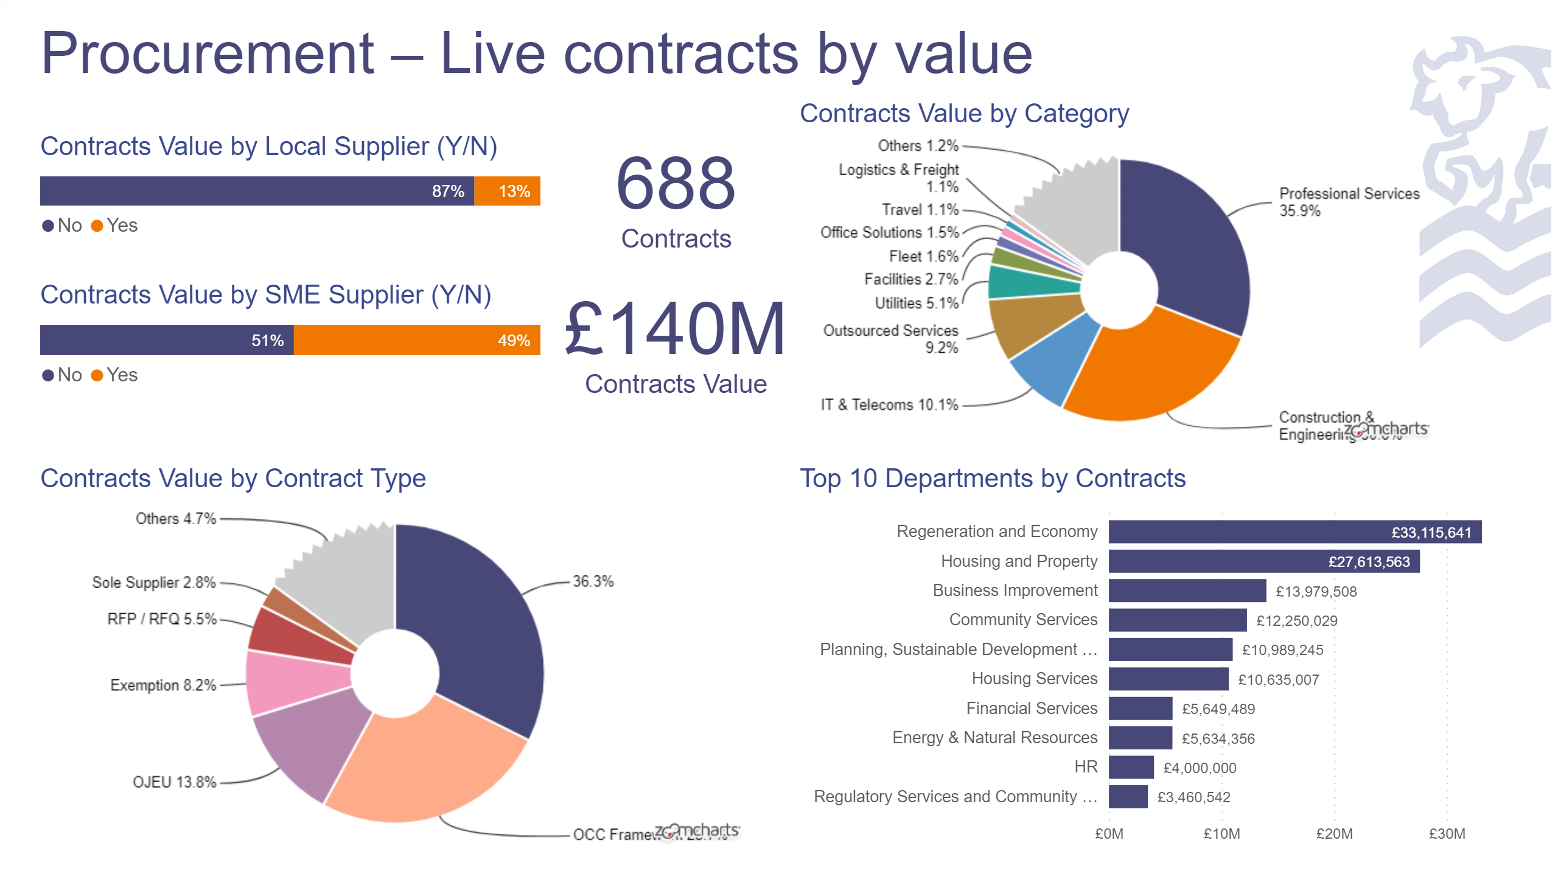](https://app.powerbi.com/groups/me/reports/60ce4377-70fa-4827-991f-adeb657d7867/ReportSectionb21603ef657e62ced06e?pbi_source=PowerPoint)**

**August 2022**

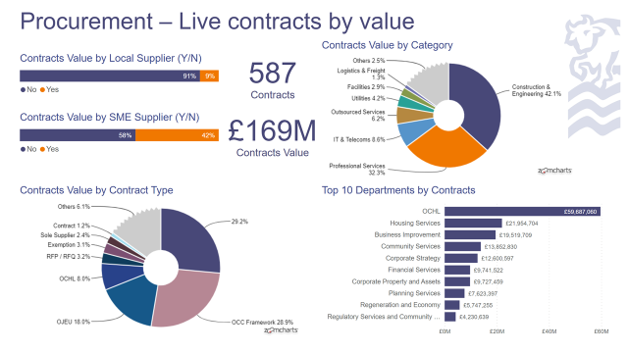

## 5.4 Exemption Requests

Service Heads are able to request exemptions from following the procurement process in a limited number of instances including Emergencies and when no competitive market exists (sole supplier). Such requests require authorisation by the Head of Financial Services and where such exemptions are in excess of £100,000 in conjunction with Head of Law and Governance.

The chart below indicates the number of exemptions over the last 3 years. Procurement have worked with services to reduce the number of requests over the years in an effort to drive more value for money.

## 5.5 Tenders undertaken via the Procurement Portal

Procurement monitor the number and type of procurements run on the Procurement Portal. There are competitions undertaken outside of the portal which cannot be tracked due to the devolved nature of the council procurement structure. Those undertaken outside of the portal are generally lower value or call offs from a framework utilising the buying organisations systems.

There is a Regulatory requirement for electronic tendering and within the Constitution it sets out the requirement to administer quotations and tenders through the Councils portal to ensure uniformity of documentation, template terms and conditions and notifications to the required publications such as FTS (OJEU replacement) and Contracts Finder. With the current procurement underway for a new Portal offering more opportunities, its use will be further rolled out to encompass on-line evaluation and contract management.

In-line with the increase in Council Spend and the decrease in the number of exemptions, the number of competitions run on the portal has increased year on year over the last 3 year period.

|  |  |  |  |
| --- | --- | --- | --- |
| Type of Competition | April 19 - March 20 | April 20 - March 21 | April 21 - March 22 |
| Competitive Dialogue | 0 | 0 | 0 |
| Dynamic Purchasing System | 4 | 3 | 2 |
| Invitation to Tender | 13 | 19 | 16 |
| Quick Quote | 5 | 7 | 3 |
| Request for Information | 2 | 2 | 0 |
| Request for Quotation | 200 | 199 | 273 |
| **Total** | **224** | **230** | **294** |

## 5.6 Transparency reporting

As well as measuring and monitoring the above performance measures, procurement will publish transparency reports in line with the Procurement Regulations this includes but is not limited to:

* Councils Contract register (a redacted version, providing only required data)
  + [Council Contracts | Council Contracts | Oxford City Council](https://www.oxford.gov.uk/info/20023/selling_to_the_council/97/council_contracts)
* Expenditure Data on items over £500 and Government Procurement Card Transactions. This is a Regulatory requirement as set out in the Local Authorities (Data Transparency) Code 2015, requiring local authorities in England to publish information relating to expenditure over £500
  + [Our spending data | Our spending data | Oxford City Council](https://www.oxford.gov.uk/info/20157/our_spending/336/our_spending_data)

## 5.7 Key Performance Indicators

**Percentage of spend with SME’s.**

The government target for spend with SME’s is set at 33% by 2025.

Currently only direct SME spend is recorded. The recording and monitoring of indirect SME spend is more complex (for instance where the council appoints a contractor for a build contract who is not an SME, however that contractor uses SME’s in their supply chain to deliver the contract).

Oxford Direct Services, one of the Council’s main suppliers is not classed as an SME.

**The percentage of spend with Local suppliers**

There is no set Government target for this.

The Council can only record direct local spend not indirect (I.e. the Council appoint a contractor for a build contract who is not a local supplier, however that contractor uses suppliers in their supply chain to deliver the contract who are based in Oxford).

**Percentage of undisputed invoices paid within 30 days of receipt.**

|  |  |  |  |
| --- | --- | --- | --- |
|  | 2019_2020 | 2020_2021 | 2021_2022 |
| Paid within 30 days of receipt | 16147 | 13299 | 14346 |
| Total no of invoices | 17138 | 14350 | 15470 |
| Percentage paid within 30 days | 94.22 | 92.68 | 92.73 |

# 6 Contract management

The process of managing agreements from their creation through to their execution by the chosen party, and to the eventual termination of the contract.

To deliver an effective, efficient procurement service the team have the following capabilities and are able to introduce a higher level of contract management to all Council contract managers.

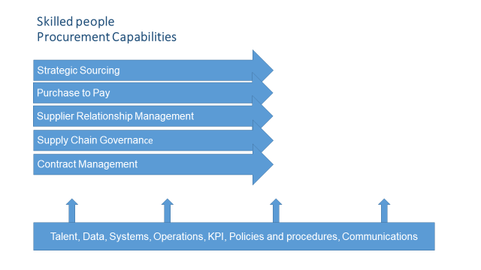

To aid devolved procurement the Procurement Team have introduced a number of tools to support the contract management lifecycle.

Procurement will continually review and update the documents in line with external Regulations and internal rules and will work with service areas to ensure that contract managers understand the requirements from both the buyer and supplier perspective.

# 7. Social Value

The Public Services (Social Value) Act 2012 which came into force on 31st January 2013 applies when a procuring authority in England procures the provision of services, or the provision of services together with the purchase or hire of goods or carrying out of works, that is subject to Part 2 of the Public Contracts Regulations 2015. The Act places a requirement on commissioners to consider the economic, environmental and social benefits of their approaches to procurement.

Social value can be defined as the additional benefit to the community from a procurement process over and above the direct purchasing of goods, services and or works.

Adopting social value, economic and environmental factors alongside the typical price and quality considerations into procurement processes and procedures, increase the potential for sustainability in a contract.

The Council requires quotes and tenders to include a minimum 10% social value weighting (an increase of 5% from the previous procurement strategy) where proportionate and relevant. Where a supplier proposes to deliver social value as part of a contract, the Council must ensure these commitments are adhered to using suitable KPIs. Procurement will work with commissioning officers and contract managers throughout the procurement lifecycle to incorporate social value completely in the process. In the last 2 years there has been significant success and in this new strategic period Procurement intend to further increase the commitments and monitoring of social value.

To support suppliers Procurement will publish a local Oxford version of the National TOM’s (a range of social value themes, outcomes and measures) on the internet under ”Selling to the Council” by January 2023 and will offer training and support to potential suppliers to the Council in this area as part of the “How to Tender” workshops.

The Council’s commitment to Community Wealth Building and economic inclusion also recognises the social value inherent in spending money within the local economy and through socially purposeful organisations. The council will encourage procuring officers to use legally compliant processes to open up tender opportunities for local SMEs, and VCSE organisations (such as reserve contracts and direct awards for lower value contracts) where it is possible to demonstrate that value for money and quality thresholds can be met.

Appendix 2 provides commissioning officers a social value flowchart which they will consider for all tenders.

**Oxford Living Wage**

The Council incorporates the Oxford Living Wage or National Living Wage Foundation rate into its standard template documents ensuring that local suppliers pay a fair wage to employees. The Council cannot legally enforce this, however it is taken into consideration when reviewing the tenderers submitted costs.

# 8 Sustainable Procurement

Sustainable procurement is the act of adopting social, economic and environmental factors alongside the usual price and quality consideration by the organisation handling the procurement process and procedures. The approach seeks to ensures that the organisation meet their need for goods, services, works and utilities in a way that achieves value for money on a whole life basis in terms of generation benefits not only to the organisation but also to society and the economy whilst minimising damage to the environment.

A sustainable Procurement Guide has been developed which incorporates what sustainable procurement is, why it matters, consideration in the procurement process, a checklist of considerations and how to manage sustainability post award of Contract.

An extract from the guide is detailed in Appendix 2.2 and must be considered for all procurements with a value in excess of £5m per annum.

It is hoped that with the Council’s drive towards a zero carbon Oxford this should also be considered in contracts with a lower value.

# 9 Ethical Procurement

Ethical procurement is procurement which ensures that suppliers and the organisations in their supply chains are monitored on a regular basis to assess whether workers’ rights and labour conditions conform to the International Labour Organisation core conventions. Ethical procurement should ensure that there is no disadvantage to those working or living on or near a supply site and that the price paid for the product reflects a fair and equitable market value.

[The Oxford City Council Equality, Diversity and Inclusion Strategy, March 2022](https://www.oxford.gov.uk/info/20356/equality_diversity_and_inclusion_strategy) provides a framework for how procurement can adapt its supply chain initiatives to meet equality criteria as enshrined in the Equality Act 2010 and the Oxford City Council EDI Strategy. To support the Equality Diversity and Inclusion team by embedding principles in the procurement process

* An EDI Procurement Guide an extract of which is shown in Appendix 2 has been developed alongside Equalities steering group
* Procurement have embedded clauses in the standard council tender documents including the following questions
  + As an organisation, do you publish/gather gender pay-gap data and information?
  + Do you provide work-place adjustments for staff with disability (as defined in the Equality Act 2010) such as mobility requirements, technological support, etc.?
  + Do you have process in place that monitors and responds to complaints related to discrimination?

If the supplier has not demonstrated to our satisfaction that they abide by these rules or have not made adjustments to rectify non-compliance the Council would reserve the right to reject the bid.

**Modern Slavery Act 2015**

The modern slavery regulations came into force on 29 October 2015. The Modern Slavery Act requires businesses in the UK to prepare a slavery and human trafficking statement for each financial year. The requirement to prepare a slavery and human trafficking statement applies to commercial organisations with an annual turnover – or group turnover - of at least £36 million. Organisations have to be transparent about what they are doing to tackle modern slavery, not just within their own operations, but in their supply chains as well.

The Council support the Act by ensuring that suppliers tendering for contracts disclose whether the Modern Slavery Act 2015 is applicable in terms of compliance with annual reporting. If applicable, Modern Slavery statements are checked and logged on the contracts register.

Please see Appendix 2 (Ethical Procurement) for the questions applied to standard tender documentation.

**Fair Tax**

The Council has signed up to Fair Tax Principles. While there are limits to our power, we will do what we can, and will also support the Fair Tax Foundation to lobby for more powers around procurement. At the moment we can exclude suppliers who have been proven to have had tax offences but we are prevented from specifying ‘responsible tax’ as a contract award criteria, e.g., a policy shunning the artificial use of tax havens, as ‘tax’ cannot be linked straightforwardly to the subject matter of a contract.

Signing up to the fair tax principles means that we support the proper accounting for and payment of tax and specifically for:

* Ensuring IR35 is implemented robustly and a fair share of employment taxes are paid by contractors.
* Shunning the use of offshore vehicles for the purchase of land and property, especially where this leads to reduced payments of stamp duty.
* Undertaking due diligence to ensure that not-for-profit structures are not being used inappropriately by suppliers as an artificial device to reduce the payment of tax and business rates.
* Demanding clarity on the ultimate beneficial ownership of suppliers, be they UK based or overseas, and their group consolidated profit and loss position, given lack of clarity could be strong indicators of poor financial probity and weak financial standing.

We have included a question into the selection phase of a tender to enable it to ascertain whether there is a concern prior to awarding an in scope contract (above threshold).

# 10 Conclusion AND SUMMARY

Procurement has evolved over the last 2 years taking the procurement register from a difficult to manage excel spreadsheet to a manageable SharePoint tool enabling procurement to effectively engage with internal and external stakeholders in the timely management of their contracts.

This has resulted in the start of contract rationalisation, a reduction in the level of exemptions being requested, the management of an increase in the number of competitions undertaken with no overhead increase to the team.

The team has worked with stakeholders to utilise skills within the Council to offer Frameworks in both Electric Vehicle Charging and Modular off-site builds which are open to other local authorities to use where the awarded supplier will pay a small fee to the Council.

Procurement in the Council had a voice in the Transforming Public Procurement paper and is in a strong position to adapt to changes that are currently going through parliament in the Procurement Bill 2022 which is expected to be authorised in 2023 with implementation within 6 months in 2023.

A new procurement portal will be introduced in Autumn 2022, and with that we expect to move to a more digitalised procurement process i.e. incorporating on-line evaluation, more templates on-line, streamlining the tendering process and enabling greater speed to access local suppliers specifically for below threshold procurements.

# 11 Action Plan to deliver the strategy

An action plan has been developed by the Procurement Team to deliver the strategy details of which are given in Appendix 3

# 12. Glossary

CWB Community Wealth Building – a people centred approach to local economic development, which redirects wealth back into the local economy

FTS Find a Tender Service – replacement for OJEU a portal for high value UK notices for publication of new procurements

H & S Health & Safety

KPI’s Key Performance Indicators a quantifiable measure used to evaluate the success of Suppliers in meeting service level objectives

OJEU Official Journal of the European Union – a portal for high value notice publications of new procurements – replaced by FTS since Brexit.

SLA’s Service Level Agreements – level of service expected by a customer from a supplier

SME Small and Medium sized Enterprises defined by number of employees and turnover

SV Social Value – measures the positive value businesses create for the economy, communities and society

SV Weighting The percentage weighting applied in the evaluation stage of a tender process.

VCSE Voluntary Community and Social Enterprise – a non-governmental organisation, which principally reinvests its surpluses to further social, environmental or cultural objectives.

# Appendix 1

## How Procurement will support internal stakeholders

Procurement will support all new employees to the Council and its entities by delivering a range of monthly training courses (the courses are also available as a refresher for existing employees). The courses include, but are not limited to:

* + Procurement overview incorporating the external Regulations and the internal rules (the Constitution);
  + Procure to Pay – Training of the Councils financial management system, Agresso ;
  + Procurement Portal training;

Procurement will attend service area meetings when required to support and offer guidance in the planning process where new contracts / contract extensions may be required.

As part of its Service Level Agreement to internal stakeholders and to ensure compliance with Regulatory requirements, Procurement will continue to:

* Monitor SME and Local spend;
* Respond to requests for new supplier set up within 5 days (in conjunction with the payment team);
* Publish transparency reports quarterly on the Council website;
* Respond to emails sent to [procurement@oxford.gov.uk](mailto:procurement@oxford.gov.uk) within 24 hours (next working day);
* Run tender processes within Regulation guidelines;
* Adhere to agreed service levels with both ODSL and OCHL as agreed from time to time.

A range of templates to support the contract lifecycle will continue to be updated and available.

### Contract Management

To support internal stakeholders in the management of the Council contracts procurement have produced a number of guides and assessments. All documents can be found on the Intranet

* A contract management guidance document detailing the Contract Manager Obligations;
* A selection of contract management KPI’s and SLA’s,
  + Guidance developed following an audit in 2020 where it was found that Key Performance Indicators and Service Level Agreements had not been incorporated as a standard in the tendering process.
  + This can be found at appendix 2 and on the intranet and will continuously evolve.
* An equality and diversity impact assessment;
* A sustainability impact assessment ;
* A number of other tools to support the contract Management process

Procurement will continually review and update the documents in line with external Regulations and internal rules and will work with service areas to ensure that contract managers understand the requirements from both the buyer and supplier perspective.

All Guidance documents and templates can be found at [Procurement Documents and Templates - tasks and guides](http://occintranet/task/procurement-documents-and-templates/)

### Integrated Contract and Commercial Capability

Contract Management must be embedded in a more holistic way across the Council and commercial knowledge of both the buyer and seller side understood if the Council is to improve its reputation as a good customer to do business with. This will increase the number of suppliers that wish to tender for Council opportunities which will ultimately result in better value for money (cost and quality).

The following diagrams details the required integrated Contract and Commercial Capability and contract lifecycle the Council buyers will need to understand and follow.

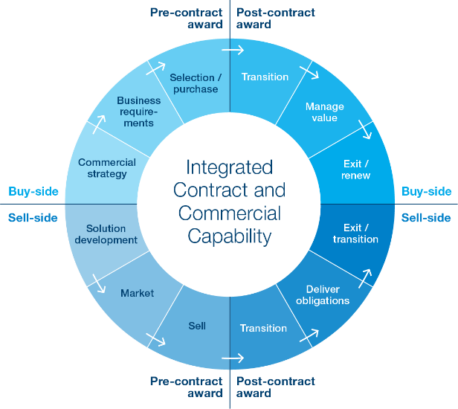

### Contract Lifecycle Management

Contract Lifecycle Management has a number of key elements and can be depicted diagrammatically as:

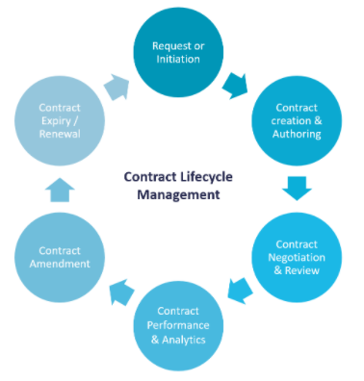

The Procurement Team have developed a contract Management Guide for Managers (Found on the intranet [Procurement Documents and Templates - tasks and guides](http://occintranet/task/procurement-documents-and-templates/)) and Procurement will support and train if required commissioning and contract managers throughout the procurement process but more specifically in ensuring that the contract delivers over and above what is expected by following the Contract Lifecycle Management including

1. Request or initiation (new or review an existing contract)
2. Contract creation & authoring (assemble a contract using existing and approved templates – self service capability)
3. Contract negotiation & Review (version control & audit trail)
4. Contract approval & execution (correct approval, signing & sealing)
5. Contract performance and analytics (milestones, obligations, payments, rebates, discounts) tracking, assigning and completing is critical to achieving the full value from the contract.
6. Contract amendment (part of the contract lifecycle whether we like it or not) dealt with efficiently without compromising the process or the guidelines in place
7. Contract expiry or renewal (using the procurement contract register/pipeline)

Procurement will keep up to date with relevant training available and will encourage commissioning officers and contract managers within the authority to access external training courses available on the subject such as the Contract Management Foundation course on offer from the Government Commercial College

[Foundation (govcommercialcollege.co.uk)](https://www.govcommercialcollege.co.uk/enrol/index.php?id=3)

# Appendix 2

## KPI and SLA Monitoring

### KPI Reporting

A guidance document has been developed by the Procurement Team to support commissioning officers and contract managers in the contract management and performance of the contract.

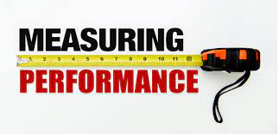

**Introduction**

It is good contract management to know that you are getting what you contracted for. This may be as simple as confirming on time delivery of goods that conform to specifications. However, with repeat business and/or more complex service requirements it makes sense to monitor performance consistently throughout the contract.

It is important to understand that Key Performance Indicators (KPIs) and Service Level Agreements (SLAs) are not the same, even though there is an overlap.

Quite simply, KPIs are the way you measure how well individuals, business units, projects and companies are performing against their strategic goals (the contract).

A SLA is also a tool to gauge performance, but it is different to a KPI, it’s an agreement detailing meaningful measurements of what the client will receive, the quality and timing, so that both the service provider and the client can clearly assess performance and any remedies or penalties, if any, should the agreed service levels not be achieved.

The fact that SLAs must define the measurements of the service delivery means that many SLAs define KPIs.

The level and frequency of performance monitoring is dependent on the value and criticality of the contract to the buying organisation.

In order to measure KPIs it is important that they are SMART (Specific, Measureable, Achievable, Relevant and Timely).

The full guide with KPI Assessment template and example Service Levels and Key Performance Indicators structured into Quality, Delivery and Cost can be found on the intranet

[Procurement Documents and Templates - tasks and guides](http://occintranet/task/procurement-documents-and-templates/)

## Social Value, Sustainability and Ethical Procurement

### Social Value

Procurement have and will continue to develop a local Oxford version of the National TOMs (OxTOMs) (Themes Outcomes and Measures) along with a Social Value guidance

To support OxTOMs a social value guidance document has been developed and will be updated in-line with any amendments to OxTOMs.

It can be found on the intranet at [Procurement Documents and Templates - tasks and guides](http://occintranet/task/procurement-documents-and-templates/)

The following flowchart should be considered by all commissioning officers in conjunction with the OxTOMS

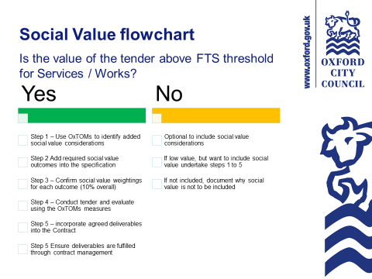

### Sustainable Procurement

#### Sustainable Procurement Guide

This Sustainable Procurement checklist must be completed by the lead project officer prior to commencing all procurements over £5m, providing answers to each question in the ‘‘Response’ section.



| Procurement title: |  |
| --- | --- |
| Lead officer: |  |
| Date checklist completed: |  |

|  | Y | | N | | N/A | Response |
| --- | --- | --- | --- | --- | --- | --- |
| Step 1. Identifying Needs | | | | | | |
| 1.1 Have you challenged the need for the procurement? |  | |  | |  |  |
| 1.2 Have the quantities been reviewed and checked for accuracy? |  | |  | |  |  |
| 1.3 Is Cabinet Approval required?  *If yes please refer to the Carbon and Environmental Considerations in Cabinet Reports on page 6.* |  | |  | |  |  |
| Step 2. Developing the Business Case | | | | | | |
| 2.1 Will this procurement bring us closer to or further away from our commitment to becoming a Net Zero carbon council by 2030 and Net Zero carbon city by 2040? *For example, does it increase or decrease:*   1. *Energy use**?* 2. *Transport movements**?* 3. *Waste generation**?* |  | |  | |  | Include response on a) energy use b) transport movements and c) waste generation. |
| 2.2 Will this procurement improve environmental quality or reduce it? *For example*:   1. *Will it Improve* *air quality* *in Oxford?* 2. *Will* *biodiversity* *or the natural environment be impacted/enhanced by this project?* |  | |  | |  | Include response on a) air quality and b) biodiversity/ natural environment |
| 2.3 Will this procurement help Oxford and its residents become more or less resilient to climate change? *For example:*   * 1. *Will it have an impact on* [*flooding*](#_Adaptation_(flooding)) *or communities impacted by flooding?* |  | |  | |  | Include response on flooding |
| 2.4 What mitigation measures have been identified to address any negative impacts/ maximise positive impacts for 2.1 – 2.3 above? |  | |  | |  |  |
| Have you used a whole life costing approach in your business case? |  | |  | |  |  |
| 2.5 Have you requested information from suppliers about their sustainability impacts, including:   * 1. Ecological footprint calculations.   2. Their carbon reduction plan and GHG emissions reporting/ inventories covering scope 1, 2 and 3 emissions and the proportion of their annual revenue that comes from the Council.   3. Net Zero targets compatible with Oxford City Council’s 2040 goal. |  | |  | |  |  |
| Have you asked your supplier for evidence of best practice in environmental management (e.g. ISO 14001 certification). |  | |  | |  |  |
| Step 3. Defining the Procurement Approach and Selecting Suppliers to Tender (or Quote) | | | | | | |
| 3.1 If you are proposing to use an external framework, have you assessed the extent to which sustainability has been addressed in its procurement? |  | |  | |  |  |
| 3.2 If your contract value is *below* the Find a Tender Service threshold, have you identified potential local suppliers? |  | |  | |  |  |
| 3.3 If your contract value is *above* the Find a Tender Service threshold, have you alerted local suppliers to the tender or invited local suppliers to quote? |  | |  | |  |  |
| 3.4 If using a pre-qualification questionnaire (PQQ), have you added any supplementary sustainability criteria to your contract (see mitigation examples in appendix 2)? |  | |  | |  |  |
| 3.5 For goods contracts have you checked and used DEFRA’s sustainable specifications designed for procurers: ‘[Government Buying Standards](http://sd.defra.gov.uk/advice/public/buying/)’? |  | |  | |  |  |
| Step 4. Tendering and Evaluation | | | | | | |
| 4.1 Have the identified environmental impacts (listed above) been addressed in your contract specification with corresponding sustainability objectives? |  | |  | |  |  |
| 4.2 Have you used an outcome-based specification as far as possible? |  | |  | |  |  |
| 4.3 Have you included a requirement for monitoring environmental impacts and performance during contract delivery? |  | |  | |  |  |
| 4.4 Have you set targets for improvement in environmental performance over the life of the contract? |  | |  | |  |  |
| 4.5 Have you asked for sufficient information to enable evaluation of whole life costs if relevant to this procurement? |  | |  | |  |  |
| Step 5. Awarding and Implementing the Contract | | | | | | |
| 5.1 Have you given unsuccessful bidders feedback on the sustainability aspects of their tenders? |  |  | |  | |  |
| 5.2 Have you put processes in place with the appointed supplier for monitoring and reporting on sustainability performance? |  |  | |  | |  |

Further guidance can be found on the intranet [Procurement Documents and Templates - tasks and guides](http://occintranet/task/procurement-documents-and-templates/)

### Ethical Procurement

* The following clauses are in the standard council tender documents:

|  |  |  |  |
| --- | --- | --- | --- |
| **Section 7** | **Modern Slavery Act 2015: Requirements under Modern Slavery Act 2015** [1] | | |
| **7.1** | Are you a relevant commercial organisation as defined by section 54 ("Transparency in supply chains etc.") of the Modern Slavery Act 2015 ("the Act")? Which means do you operate at all within the UK with a turnover in excess of 36M | | **Yes** |
| **N/A** |
| **7.2** | If you have answered yes to question 7.1 please confirm that  a) are you compliant with the annual reporting requirements contained within Section 54 of the Act 2015?  b) Please provide the relevant URL link to enable the authority to view your full statement. | If Yes - a) Yes/No  b) URL: | **Yes** |
| If No - Please provide an explanation | **No** |

|  |  |  |  |
| --- | --- | --- | --- |
| **8.5 Equality outcomes and** [The Equality Act 2010](https://www.legislation.gov.uk/ukpga/2010/15/contents) | | | |
| [The Oxford City Council Equality, Diversity and Inclusion Strategy, March 2022](https://www.oxford.gov.uk/info/20356/equality_diversity_and_inclusion_strategy) **provides a framework for how procurement can adapt its supply chain initiatives to meet equality criteria as enshrined in the Equality Act 2010 and the Oxford City Council EDI Strategy.** | | | |
| a. | As an organisation, do you publish/gather gender pay-gap data and information? | **Yes** | **No** |
| b. | Do you provide work-place adjustments for staff with disability (as defined in the Equality Act 2010) such as mobility requirements, technological support, etc. | **Yes** | **No** |
| c. | Do you have process in place that monitors and responds to complaints related to discrimination? | **Yes** | **No** |

The full Guidance document can be found on the intranet [Procurement Documents and Templates - tasks and guides](http://occintranet/task/procurement-documents-and-templates/)

# Appendix 3 Key Priority Action Plan and reporting framework

|  |  |  |  |
| --- | --- | --- | --- |
| Priority | Actions to Achieve | Timeline | Lead Procurement Officer |
| Social Value and Climate Change | Finalise OxTOMs | September 2022 | Procurement Manager |
| Brief Heads of Service and Roll out OxTOMs | October 2022 | Procurement Manager |
| Include minimum award threshold of 10% for relevant procurements | In Force Now | Procurement Specialist |
| Improve Contract management and monitoring of social value and sustainability | January 2023 | Procurement Specialist |
| Deliver the procurement Portal | Award Contract | Autumn 2022 | Procurement Specialist |
| Train all Buyers | Autumn 2022 | Procurement Specialist |
| Transfer Data from incumbent provider to New Provider | Autumn 2022 | Procurement Specialist |
| Collaborative procurement | How to tender workshops | November 2022 then monthly | Procurement Specialist |
| Meet the buyer | November 2022 the yearly | Procurement Specialist |
| Working with company entities | In Force Now | Procurement Manager |
| Industry days | When required | Procurement Specialist |
| Working with Social Enterprise Companies | In Force Now | Procurement Manager |
| Constitution Review | Continuous review on a yearly basis | Complete 2022 – review 2023 | Procurement Manager |
| Procurement template review | Continuous review |  | Procurement Officer |
| Procurement Training | Procurement Overview | Delivered monthly | Procurement Specialist |
| Agresso | Delivered monthly | Procurement Specialist |
| Portal training | Autumn onwards then monthly | Procurement Specialist |
| Commercial Focus | Sell our services |  | Procurement Manager |
|  | Manage the EV DPS | On-going | Procurement Specialist |
|  | Manage the sustainable housing framework | On-going | Procurement Specialist |
| Contract Management | Basic contract management training | January 2023 | Procurement Manager |
|  | Basic negotiation training | January 2023 | Procurement Manager |
| Spend Data | Analysis of Tail end spend (Maverick / Rogue spend) | Initial review by February 2023 then yearly | Procurement Officer |

1. For background see Home Office publication

   https://www.gov.uk/government/uploads/system/uploads/attachment_data/file/471996/Transparency_in

   _Supply_Chains_etc__A_practical_guide__final_.pdf